

**ePITome v3.5**

User guide



## 

Table of contents

**Product overview** **3**

**Switch and Jumper settings** **4**

**External Connections** **4**

**System power and charging requirements** **5**

**LED States** **5**

**Setting up hardware** **6**

# Product overview

# 

***Front Back***

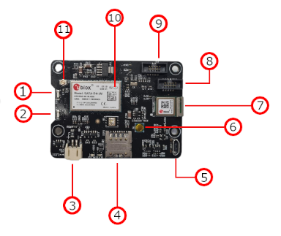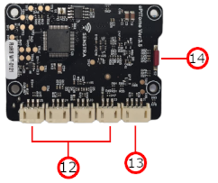

| **#** | ***Component*** | ***Description*** |
| --- | --- | --- |
| 1 | *LED (D1)* | Programmable LED used for displaying system states. |
| 2 | *LED (D2)* | Programmable LED used for displaying system states. |
| 3 | *Power input* | 2-pin socket for accepting Vcc (9 volt max., 1A min.) |
| 4 | *SIM tray* | Insert your SIM card into the tray to enable network connectivity. |
| 5 | *USB-micro interface* | Serial bus interface for debugging and device handling |
| 6 | *Reset button* | Pressing this will hard reset the device. |
| 7 | *Bluetooth module* | Enables bluetooth connectivity to the device. |
| 8 | *JTAG/SWD interface 1* | SWD interface for programming BLE modem |
| 9 | *JTAG/SWD interface 2* | SWD interface for programming MCU. |
| 10 | *Modem* | Connects the device to Narrowband or CAT-M1 networks |
| 11 | *Antenna interface* | U.Fl connection used for the attachment of narrow band antennas |
| 12 | *Sensors interface* | J2-J4 sockets for sensor inputs. Each can be implemented to accept either analog or digital signals. |
| 13 | *UART interface* | J1 socket for sensors with UART capabilities. |
| 14 | *Reed switch* | Reed switch used to interact with the device. Can toggle multiple modes. |

# Switch and Jumper settings

| ***Reed switch***  *Reed switch settings are fully user configurable so customers have full flexibility in the use of their device.* | |
| --- | --- |
| ***Action*** | ***Reaction*** |
| *Example Mode 1: hold for 1 seconds* | *Poll sensors mode* |
| *Example Mode 2: hold for 3 seconds* | *Maintenance mode* |
| *Example Mode 3: hold for 5 seconds* | *Enable Bluetooth broadcast for 30 seconds.* |

# External Connections

| ***External connection ports***  *The device has multiple ports for external connection of sensors and utility.* | | |
| --- | --- | --- |
| ***Annotation #*** | ***External connection*** | ***Description*** |
| *3* | *Power Supply input* | *2-pin connector for providing Vcc input voltage to power the system. Nom: 7.2V 800mA min.* |
| *5* | *Micro-USB interface* | *Micro-USB socket for the use of serial bus connection for debugging and serial communication.* |
| *8* | *SWD interface 1* | *Connect to the Bluetooth Low Energy Module and program independently for troubleshooting/debugging and development.* |
| *9* | *SWD interface 2* | *Connect to the MCU for programming and development.* |
| *11* | *U.Fl/ Molex conntector* | *Use the U.Fl connector to attach a suitable antenna for the system.* |
| *12* | *Sensor inputs 2 - 5* | *For interfacing with a range of 1-wire and analog signals. Individually programmable to be used as digital or analog I/O.* |
| *13* | *Sensor input 1* | *For interfacing with a range of UART enabled sensors.* |

# System power and charging requirements

| ***Power and charging requirements*** | | |
| --- | --- | --- |
| ***Supply voltage*** | *5 volts* | *minimum* |
|  | *9 volts* | *maximum* |
| ***Supply current*** | *800mA* | *minimum* |
| ***Battery options*** | | |
| *Long-life module* | *Lithium Thionyl Chloride, 7.2V / 14000mAh* | |
| *Solar module* | *Lithium-ion storage, 3.6V / 2600mAh; 7 volt PV input max.* | |
| *reCharge module* | *Lithium-ion storage, 7.2V/5200mAh; 12 volt input max.* | |
| *Ext. supply module (DC)* | *Lithium-ion back-up, 7.2V/2600mAh; (24VDC input max.)* | |
| *Ext. supply module (AC)* | *Lithium-ion back-up, 7.2V/2600mAh; (240VAC input max.)* | |

# 

# LED States

| ***LED indicators*** *LED’s (D1) and (D2) are user programmable Red/Green. Some passive LED’s exist on the board, but are unpopulated to reduce overall power consumption.* | | |
| --- | --- | --- |
| ***LED*** | ***LED status*** | ***Description*** |
| LED(D1) | User defined | LED(D1) on side of board is user programmable. |
| LED(D2) | User defined | LED(D2) on side of board is user programmable. |
| LED(D6) | Solid red | D6 is illuminated when a USB connection is established. |
| LED(LED2) | Solid red | LED2 will illuminate when Vcc is attached however, It is not populated to conserve power when active. |
| LED(LED4) | Solid orange | LED4 illuminates when power is applied to modem. Not populated to conserve power. |

# 

# Setting up hardware

*Pre-requisites:*

*We supply a 2-pin power cable for our customers to develop their own power packs, but if required, we can supply ready-to-go battery packs as well. If you’re making your own, ensure the power pack is capable of delivering at least 5 volts 1 Amp, with a maximum of 9 volts so you don't overwork the on-board regulator.*

*Note: For initial stages of development, we recommend using a benchtop supply so there is no need to keep replacing batteries.*

*For network testing and remote connection capabilities, users must insert an active SIM card into the SIM tray to use this feature.*

*To begin developing the hardware:*

1. *Connect an antenna to the U.Fl connector on the board.*
2. *Ensure SIM card has been correctly installed. *The correct direction is scribed into the top of the tray for reference.\**
3. *Connect power to the board using the supplied power cable.*
4. *To flash and program the MCU, connect the ST-Link assembly (as shown below) to the SWD connector (P3 on the board). Connect the USB side of the assembly to your computer.*

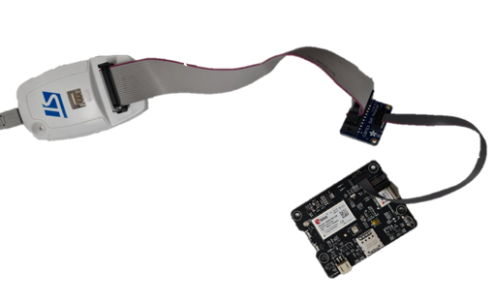

1. *To communicate using the serial bus and read serial output, you must connect to the board using the Micro-USB socket.*
2. *If you are working with any of Senstras sensors, you can directly interface them with sensor inputs J1 - J5, depending on the type of sensor. If you are working with your own sensor or controls systems the pin map for the JST connectors are as follows:*

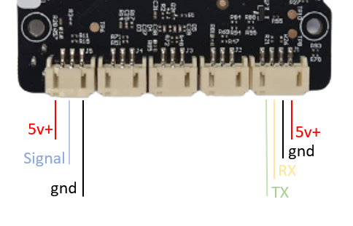

1. *Now that your device and hardware is set up for development, find out how to get started programming your device in the ‘Getting Started Guide For FreeRTOS’.*